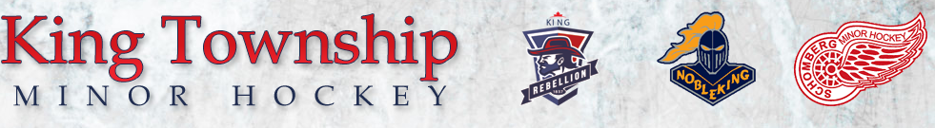

Aug 11, 2020.

The Ontario Hockey Federation has recently released its Stage 3 Return to Hockey guidelines. CLICK HERE to download the guidelines. There has been significant planning and discussions within the hockey community as it relates to the structure and details of the upcoming 2020/2021 season.
Highlights:
- Season will start with non-traditional programming (ie. 3 on 3 or 4 on 4)
- Players will participate in a hockey “bubble” to minimize risk of outbreaks
- The season will change in cycles (ex. Every 4 weeks) as restrictions change by province or local health
- Programming across Ontario (GTHL, OMHA, OWHA, etc) will be the same as all guidelines are provided by OHF Director
The KTMH, Schomberg, and Nobleking executive boards have been participating in meetings with the OMHA, YSMHL, SRLL, and King Township. Our goal being to develop a program that will give our members the best value, and overall experience, given the restrictions and limitations that all minor hockey associations are dealing with. Our primary concern continues to be the health and wellbeing of our athletes and their families.

On AUGUST 21st, 2020, we will host a town hall virtual meeting to discuss the 2020/21 season plan. A document will be released shortly after outlining all the details, understanding that things could change depending on the policy and recommendations of our Local Health Authority. We appreciate the patience as we work toward finalizing our season plan, and look forward to seeing you all at the rink soon.

